

**FNDB020 Accounting**

**Student Workbook**

**Lecture and Tutorial**

**Week 2**

**Updated February 2018**

# Accounting Terms

Check your understanding of these terms which will be used in this week’s lecture.

There is space to add your own new words to the list. Add to Quizlet.

|  |  |
| --- | --- |
| **Term** | **Definition** |
| **Credit** |  |
| **Debit** |  |
| **Journal** |  |
| **Balance** |  |
| **Income** |  |
| **Ledger account** |  |
|  |  |
|  |  |
|  |  |
|  |  |
|  |  |
|  |  |
|  |  |
|  |  |
|  |  |



ASSETS



+

-

=



EQUITY



LIABILITIES



2

# Week 2: The Accounting Equation 3

## 

## Revisit Accounting assumptions introduced in Week 1

1. Accounting Principles & Assumptions provide framework for accounting systems. List them and describe in a few key words

## Revise Assets, Liabilities & Equity in the Balance Sheet:

## What are the 5 elements of accounting?



1. Define Assets.
2. Distinguish between Current and Non current assets
3. Define Liabilities
4. Distinguish between Current and Non Current (or deferred) Liabilities
5. Owners Equity means ..
6. Owner Equity is made up of …
7. Define Income (revenue)?
8. Define Expenses?



ASSETS

+



LIABILITIES

=



EQUITY



Capital



Drawings



Income



Expenses

reduce

equity

reduce

equity

improves equity

improves equity



4

## **Financial Statements (from week 1 homework) slide 32**

**Murphy’s Law Firm for the financial year ending 30 June 2018**

(2015 S3 Lecture Week

1. Prepare an Income Statement, Balance Sheet and a Statement of Changes in Equity for Murphy’s Law Firm for the year ended 30 June 2018

|  |  |  |  |  |  |  |  |  |  |  |  |  |  |  |  |  |  |  |  |  |  |  |  |  |  |  |  |  |  |  |  |  |  |  |  |  |  |  |  |  |  |  |  |  |  |  |  |  |  |  |  |  |  |  |  |  |  |  |  |  |  |  |  |  |  |  |  |  |  |  |  |  |  |  |  |  |  |  |  |  |  |  |  |  |  |  |  |  |  |  |  |  |  |  |  |  |  |  |  |  |  |  |  |  |  |  |  |  |  |  |  |  |  |  |  |  |  |  |  |  |  |  |  |  |  |  |  |  |  |  |  |  |  |  |  |  |  |  |  |  |  |  |  |  |  |  |  |  |  |  |  |  |  |  |  |  |  |  |  |  |  |  |  |  |  |  |  |  |  |  |  |  |  |  |  |  |  |  |  |  |  |  |  |  |  |  |  |  |  |  |  |  |  |  |  |  |  |  |  |  |  |  |  |  |
| --- | --- | --- | --- | --- | --- | --- | --- | --- | --- | --- | --- | --- | --- | --- | --- | --- | --- | --- | --- | --- | --- | --- | --- | --- | --- | --- | --- | --- | --- | --- | --- | --- | --- | --- | --- | --- | --- | --- | --- | --- | --- | --- | --- | --- | --- | --- | --- | --- | --- | --- | --- | --- | --- | --- | --- | --- | --- | --- | --- | --- | --- | --- | --- | --- | --- | --- | --- | --- | --- | --- | --- | --- | --- | --- | --- | --- | --- | --- | --- | --- | --- | --- | --- | --- | --- | --- | --- | --- | --- | --- | --- | --- | --- | --- | --- | --- | --- | --- | --- | --- | --- | --- | --- | --- | --- | --- | --- | --- | --- | --- | --- | --- | --- | --- | --- | --- | --- | --- | --- | --- | --- | --- | --- | --- | --- | --- | --- | --- | --- | --- | --- | --- | --- | --- | --- | --- | --- | --- | --- | --- | --- | --- | --- | --- | --- | --- | --- | --- | --- | --- | --- | --- | --- | --- | --- | --- | --- | --- | --- | --- | --- | --- | --- | --- | --- | --- | --- | --- | --- | --- | --- | --- | --- | --- | --- | --- | --- | --- | --- | --- | --- | --- | --- | --- | --- | --- | --- | --- | --- | --- | --- | --- | --- | --- | --- | --- | --- | --- | --- | --- | --- | --- | --- | --- |
| |  |  |  |  |  |  |  |  |  |  |  |  | | --- | --- | --- | --- | --- | --- | --- | --- | --- | --- | --- | --- | |  | **√** | Account Name | | $ | Asset, Liability, | | | |  | Financial | | |  | **when** |  |  |  | Equity, Income, | | | |  | Statement | | |  | **done** |  |  |  | Expense | | | |  |  |  | |  |  | Accounts payable | | 1,405 |  |  |  |  |  |  |  | |  |  | Accounts receivable | | 22,000 |  |  |  |  |  |  |  | |  |  | Advertising expense | | 20,600 |  |  |  |  |  |  |  | |  |  | Cash at bank | | 33,040 |  |  |  |  |  |  |  | |  |  | Electricity expense | | 720 |  |  |  |  |  |  |  | |  |  | Legal service income | | 155,820 |  |  |  |  |  |  |  | |  |  | Loan (due in 2020) | | 12,000 |  |  |  |  |  |  |  | |  |  | Motor Vehicle | | 36,695 |  |  |  |  |  |  |  | |  |  | Rent expense | | 32,000 |  |  |  |  |  |  |  | |  |  | Murphy, Capital | | 36,950 |  |  |  |  |  |  |  | |  |  | Murphy, Drawings | | 6,600 |  |  |  |  |  |  |  | |  |  | Prepaid Insurance | | 2,920 |  |  |  |  |  |  |  | |  |  | Unearned revenue | | 450 |  |  |  |  |  |  |  | |  |  | Wages expense | | 52,050 |  |  |  |  |  |  |  | |

|  |  |  |  |
| --- | --- | --- | --- |
| Income statement for Murphy Law  for the year ending 30/6/2018 | | | |
|  |  |  |  |
| Income |  |  |  |
|  |  |  |  |
| **less Expenses** |  |  |  |
|  |  |  |  |
|  |  |  |  |
|  |  |  |  |
|  |  |  |  |
| = Profit |  |  |  |

|  |  |  |  |  |  |
| --- | --- | --- | --- | --- | --- |
| Balance sheet at 30/6/2018 | | | | | |
| **Current Asset** |  |  | **Current liabilities** |  |  |
|  |  |  |  |  |  |
|  |  |  |  |  |  |
|  |  |  | Non Current liab |  |  |
|  |  |  |  |  |  |
| Non current Assets |  |  |  |  |  |
|  |  |  | **Equity** |  |  |
|  |  |  | Capital |  |  |
|  |  |  | **less** Drawings |  |  |
|  |  |  | **plus** profit |  |  |
| Total assets | 0 |  | Total L and OE |  |  |
|  |  |  |  |  |  |

## Business Transactions: Adele’s Garden Design Guided task (slide 34)

|  |  |  |
| --- | --- | --- |
| Date | **√** | Transaction |
| 1st Feb |  | Adele contributed $25,000 of her own savings to the business. |
| 3rd Feb |  | purchased office equipment for $2500 and paid by cheque. |
| 5th Feb |  | provided design services to clients $5000. Received $1500 in cash and invoiced the clients for the balance. |
| 12th Feb |  | paid electricity bill of $350 for February. |
| 14th Feb |  | hired a part time administration assistant for the Design business who will assist Adele in general office duties. The assistant will commence her position next month. |
| 15th Feb |  | purchased $250 office supplies on credit. |
| 16th Feb |  | received $3,500 from clients invoiced on 5th February. |
| 19th Feb |  | paid the annual insurance premium $2400. |
| 22nd Feb |  | received telephone bill $450, this will be paid next month. |
| 23rd Feb |  | provided design services $2300 and invoiced the clients. |
| 25th Feb |  | Adele pays her personal credit card invoice $1200 using her personal savings |
| 28th Feb |  | Adele withdrew $800 from the business for her personal use. |

## Summary Transaction Analysis [exam format]

|  |  |  |  |
| --- | --- | --- | --- |
| **Date** | **Assets =** | **Liabilities +** | **Equity** |
| **1st Feb** |  |  |  |
| **3rd Feb** |  |  |  |
| **5th Feb** |  |  |  |

|  |  |  |  |
| --- | --- | --- | --- |
| **12th Feb** |  |  |  |

|  |  |  |  |
| --- | --- | --- | --- |
| **15th Feb** |  |  |  |
| **16th Feb** |  |  |  |
| **19th Feb** |  |  |  |
| **22nd Feb** |  |  |  |
| **23rd Feb** |  |  |  |
| **28th Feb** |  |  |  |

## Transaction Analysis Task



**Transaction Analysis Table**

|  |  |  |  |
| --- | --- | --- | --- |
| **Date** | **ASSETS =** | **LIABILITIES +** | **OWNERS’ EQUITY** |
|  |  |  |  |
|  |  |  |  |
|  |  |  |  |
|  |  |  |  |
|  |  |  |  |
|  |  |  |  |
|  |  |  |  |
|  |  |  |  |
|  |  |  |  |
|  |  |  |  |
|  |  |  |  |
|  |  |  |  |
|  |  |  |  |
|  |  |  |  |

## Challenge Can you construct the Income statement and Balance sheet from the information in Task above? You may need your teacher’s guidance.

**Income Statement for period ended ….**

|  |  |  |
| --- | --- | --- |
|  | **$** | **$** |
| Service fee income |  |  |
| **Less Expenses** |  |  |
|  |  |  |
|  |  |  |
|  |  |  |
|  |  |  |
|  |  |  |
|  |  |  |
|  |  |  |
|  |  |  |
|  |  |  |

**Balance Sheet as at ….**

|  |  |  |  |  |  |
| --- | --- | --- | --- | --- | --- |
| **Assets** | **$** | **$** | **Liabilities** | **$** | **$** |
|  |  |  |  |  |  |
|  |  |  |  |  |  |
|  |  |  |  |  |  |
|  |  |  |  |  |  |
|  |  |  |  |  |  |
|  |  |  |  |  |  |
|  |  |  |  |  |  |
|  |  |  |  |  |  |
|  |  |  | **Owners’ Equity** |  |  |
|  |  |  |  |  |  |
|  |  |  |  |  |  |
|  |  |  |  |  |  |
|  |  |  |  |  |  |
|  |  |  |  |  |  |
|  |  |  |  |  |  |
|  |  |  |  |  |  |
|  |  |  |  |  |  |

## Double Entry Accounting (slide 42) means:



8

## Adele’s example

* On 3rd Feb [**2 accounts affected**]: Adele pays $2,500 for office supplies. This involves the accounts of office equip (asset) and cash at bank (asset); or
* On 5th Feb [**3 accounts affected**]: Adele provides design service of $5,000 to client, received $1,500 cash and invoiced $3,500. This involves the accounts: cash at bank (asset), accounts receivable (asset) and services income (income statement item, affecting equity).

|  |
| --- |
| * To increase Assets Drawings and Expenses …….. |
| * To decrease Assets Drawings and Expenses …… |
| * To Increase Liabilities Capital and Income ……. |
| * To decrease Liabilities Capital and Income ……… |

* 1. Which elements,
  2. Which accounts are impacted (must be at least 2)
  3. Are the Accounts increasing + or decreasing –
  4. **THEN** Apply Debit and Credit rules

* Apply the Debits and Credits rules to Adele’s example into the T ledger accounts

Cash at Bank Service Income

Equipment

Accs Receivable

## Apply your knowledge and skills. Analyse and then record the 4 transactions to ledger accounts:

1/5 Owner invested $50,000 cash into the business

2/5 Business purchase equipment for cash $6,600

3/5 Paid Rent $2200

4/5 Fees provided on credit to customer for $4400

Transaction analysis table

|  |  |  |  |
| --- | --- | --- | --- |
| Date | Assets = | Liabilities + | Equity (inc Income and expense) |
| 1/5 |  |  |  |
| 2/5 |  |  |  |
| 3/5 |  |  |  |
| 4/5 |  |  |  |

TRANSFER/post to general ledger

DR + Cash at Bank (A) CR- DR- Capital (OE) CR+

DR+ Equipment (A) CR- DR- Fees a/c (I) Cr+

DR+ Rent a/c (E) CR-

Accounts Receivable a/c

## What is a Trial Balance Unadjusted?



Balance the ledger Accounts and list the balances in the Trial Balance

Trial Balance at 5/5/2018

|  |  |  |
| --- | --- | --- |
| Ledger Account names | Debit | Credit |
| Cash at Bank |  |  |
| Accounts Receivable |  |  |
| Equipment |  |  |
| Capital |  |  |
| Fees |  |  |
| Rent expense |  |  |
| Total |  |  |

## Revision Colin’s Task from the ppt slide 56

## Record transaction in the General Journal

We have analysed Adele’s transaction so now we must record the transaction in the General Journal

## Business Transactions: Adele’s Garden Design Guided task

|  |  |  |
| --- | --- | --- |
| Date | **√** | Transaction |
| 1st Feb |  | Adele contributed $25,000 of her own savings to the business. |
| 3rd Feb |  | purchased office equipment for $2500 and paid by cheque. |
| 5th Feb |  | provided design services to clients $5000. Received $1500 in cash and invoiced the clients for the balance. |
| 12th Feb |  | paid electricity bill of $350 for February. |
| 14th Feb |  | hired a part time administration assistant for the Design business who will assist Adele in general office duties. The assistant will commence her position next month. |
| 15th Feb |  | purchased $250 office supplies on credit. |
| 16th Feb |  | received $3,500 from clients invoiced on 5th February. |
| 19th Feb |  | paid the annual insurance premium $2400. |
| 22nd Feb |  | received telephone bill $450, this will be paid next month. |
| 23rd Feb |  | provided design services $2300 and invoiced the clients. |
| 25th Feb |  | Adele pays her personal credit card invoice $1200 using her personal savings |
| 28th Feb |  | Adele withdrew $800 from the business for her personal use. |

|  |  |  |  |
| --- | --- | --- | --- |
| General Journal | | | |
| Date | Accounts | Debit | Credit |
|  |  |  |  |
|  |  |  |  |
|  |  |  |  |
|  |  |  |  |
|  |  |  |  |
|  |  |  |  |
|  |  |  |  |
|  |  |  |  |
|  |  |  |  |
|  |  |  |  |
|  |  |  |  |
|  |  |  |  |
|  |  |  |  |
|  |  |  |  |
|  |  |  |  |
|  |  |  |  |
|  |  |  |  |
|  |  |  |  |
|  |  |  |  |
|  |  |  |  |
|  |  |  |  |
|  |  |  |  |

## Extension work Post General Journal entries to General Ledger accounts

Work with your teacher to post the entries into the General ledger. We will look at this step in detail in Week 3

## Remember the rules



|  |  |  |
| --- | --- | --- |
|  |  |  |

TRANSFER/post to general ledger

DR + Cash at Bank (A) CR- DR- Capital (OE) CR+

DR+ CR- DR- Fees a/c (I) Cr+

DR+ CR-

Tutorial Week 2

## (2015 S3 Lecture 2)

## **MURPHY’S LAW FIRM – Operating in February**

The following transactions occurred in the business of Murphy’s Law Firm during the month of **February**:

|  |  |  |
| --- | --- | --- |
| Date | **Related Activity** | Business Transaction |
| Feb 1 |  | Obtained a loan from the bank for $100,000 |
| Feb 2 |  | Paid 6 months rent in advance, $7,200 |
| Feb 9 |  | Purchased a motor vehicle costing $25,000. Of this amount, $5,000 is a deposit, and the remaining $20,000 is due to be paid within 14 days. |
| Feb 12 |  | Paid wages of $12,000 |
| Feb 15 |  | Invoiced client for services performed, $18,000 |
| Feb 21 |  | Sent a cheque for $20,000 in payment for the motor vehicle purchased on Feb 9 |
| Feb 22 |  | Received a cheque for $18,000 from customers on account. (The customers were invoiced on Feb 15) |
| Feb 27 |  | Paid interest expense on bank loan $1,500 |
| Feb 28 |  | Received $2,000 in advance from customers for services to be provided in April. |

(hint: the accounting period is for February. revenue has not been earned yet, because the services will only be performed next month in April)

Required:

Perform a transaction analysis and prepare journal entries for the above transactions.

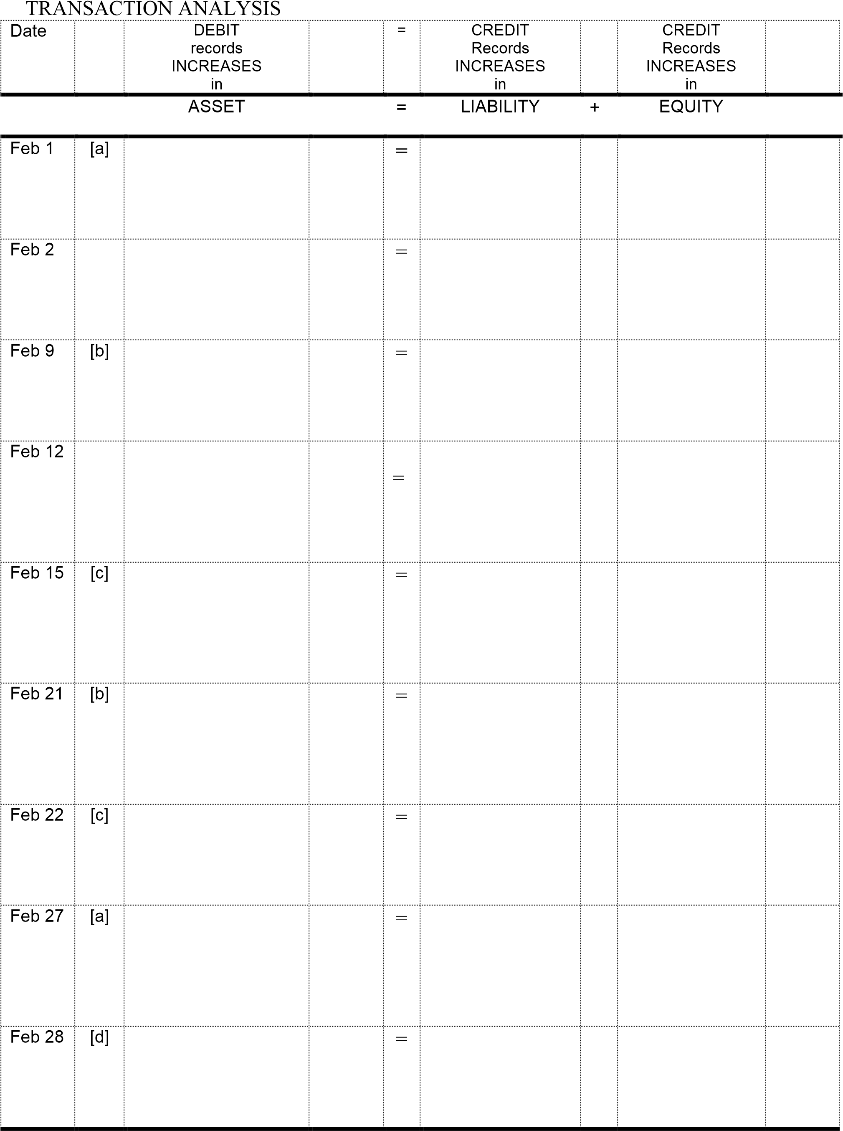

## MURPHY’S LAW FIRM (GENERAL JOURNAL)

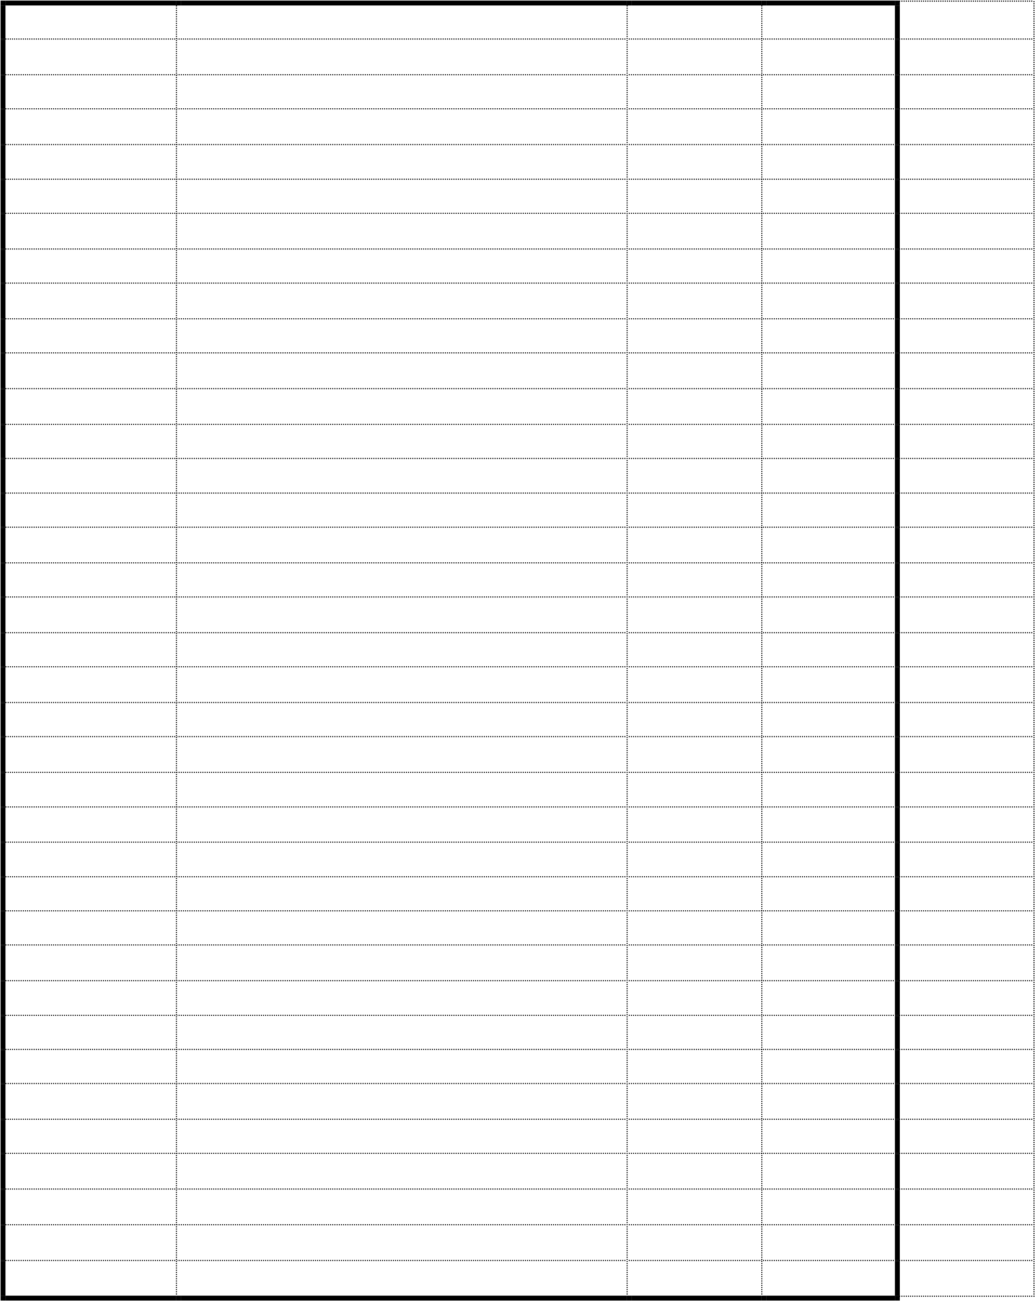

## MURPHY’S LAW FIRM – Operating in March

*(2015 S3 Lecture 2)*

The following transactions occurred in the business of Murphy’s Law Firm during the month of March:

|  |  |  |
| --- | --- | --- |
| Date | Related Activity | Business Transaction |
| Mar 1 |  | Paid advertising expense for the month of March by cheque $6,000. |
| Mar 4 | [a] | Purchased equipment costing $8,000 on credit. |
| Mar 10 | [b] | Services performed for a customer amounted to $2,000. Received cash of $500 and invoiced customer for the balance owing of $1,500. |
| Mar 15 | [a] | Paid supplier for the equipment purchased on March 4 |
| Mar 20 | [b] | Received a cheque for $1,500 for services provided on account on 10th Mar |
| Mar 22 |  | Paid the annual insurance premium of $1,800 |
| Mar 27 |  | Paid wages expense of $6,000 |
| Mar 31 |  | The owner withdrew cash of $1,000 |

Required:

Perform a transaction analysis and prepare journal entries for the above transactions.

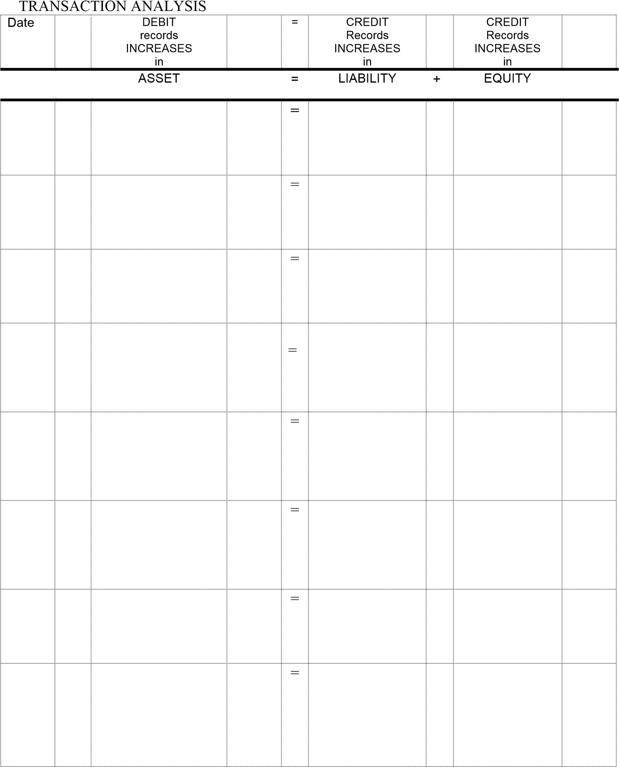

**MURPHY’S LAW FIRM (GENERAL JOURNAL**

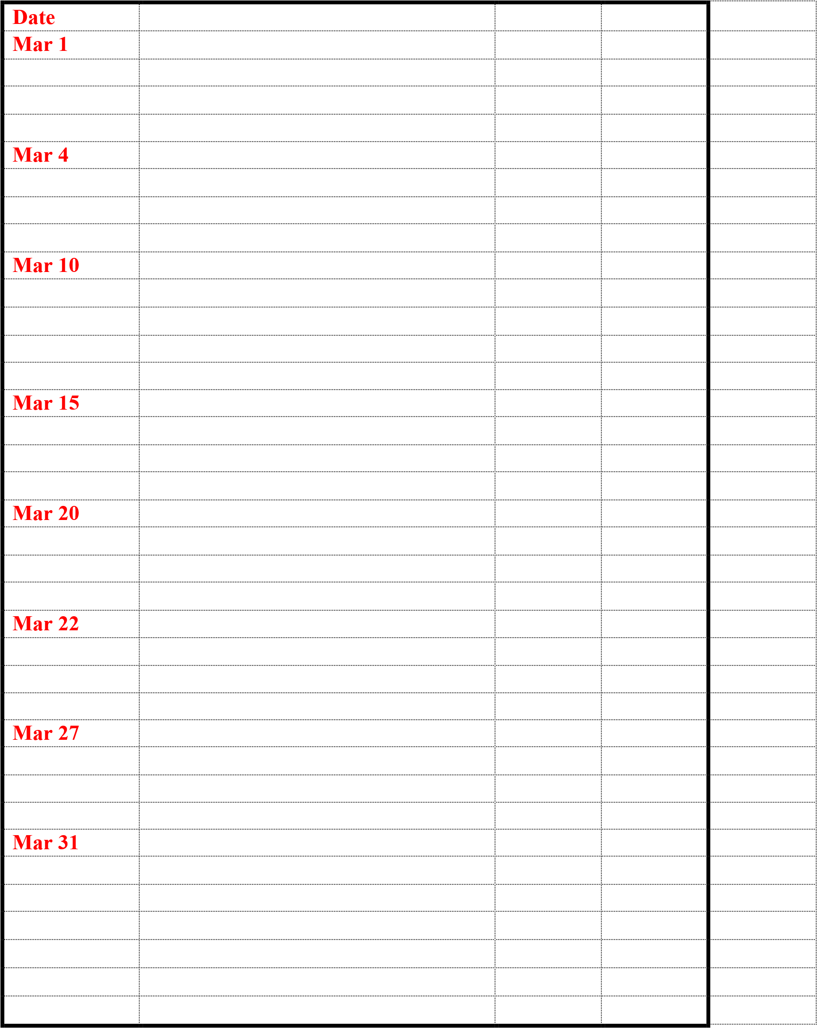

Q 3.6 Give an example of a transaction that results in:

1. An increase in one asset and an increase in a liability
2. A decrease in one asset but no change in the total assets
3. An increase in one asset and an increase in equity
4. A decrease in one asset and a decrease in a liability
5. A decrease in one asset and a decrease in equity
6. One asset increasing, one asset decreasing and one liability increasing
7. A decrease in equity and an increase in a liability

|  |  |  |  |  |
| --- | --- | --- | --- | --- |
| **Exercise 3.2** |  | **Transaction analysis** |  |  |

For each of the following transactions, indicate whether the accounts affected are an asset, a liability, an equity, an income or an expense. Also indicate whether the accounts are being increased or decreased and whether the increase or decrease is a debit or credit. Ignore GST.

1. Owner gave their personal computer to the business..
2. Employed a secretary.
3. Cash payment made for insurance 6 months in advance.
4. Purchased supplies on credit.
5. Paid a creditor using an electronic transfer.
6. Invoiced a customer for services performed.
7. Owner paid for their personal groceries using the business credit card.
8. Paid some cash and took out a loan to purchase office furniture.
9. Received cash from a customer that owed the business money.
10. Paid for an advertisement aired on television.

|  |  |  |  |  |
| --- | --- | --- | --- | --- |
| **Exercise 3.3** |  | **Effects of transactions on financial position** |  |  |

The following transactions were undertaken by Massenburg Personnel Services during the month of February 2016. Ignore GST.

1. Invoiced a client for providing advice on current employment legislation, $2400.

2. Paid salaries to staff, $3600.

3. Paid an annual subscription for access to an online data base of employment legislation until the end of January 2017.

4. Received $6000 from a client for employing staff for them in January.

5. M. Massenburg invested a further $20 000 additional capital into the business to ensure it has sufficient cash to continue operations.

6. Purchased new office furniture and equipment on credit for $12 500.

7. Invoiced a client for $7000 for providing advice regarding an industrial dispute they had with their employees.

8. Paid $720 electricity account the day the account was received.

9. Paid the firm’s lawyers for an account received from them in December for receiving legal advice, $7100.

10. Paid for the equipment purchased in (6).

11. M. Massenburg withdrew $1200 from the business bank account for personal use.

###### Required

Indicate with the appropriate letter whether each of the transactions resulted in:

(a) an increase in assets and a decrease in assets

(b) an increase in assets and an increase in liabilities

(c) an increase in assets and an increase in equity

(d) a decrease in assets and a decrease in liabilities

(e) a decrease in assets and a decrease in equity

(f) an increase in liabilities and a decrease in equity

(g) an increase in equity and a decrease in liabilities.

|  |  |  |  |  |  |  |
| --- | --- | --- | --- | --- | --- | --- |
| **Exercise 3.5** |  | **Recording transactions in general journal and** | | |  |  |
|  |  | **analysis** |  |  |  |  |

The chart of accounts of Pellham Poster Printers contained the following accounts: Cash at Bank; Accounts Receivable; Equipment; Accounts Payable; K. Pellham, Drawings; Printing Fees; Salaries Expense and Advertising Expense. Ignore GST.

The following transactions occurred during the month of June:

|  |  |  |  |  |  |
| --- | --- | --- | --- | --- | --- |
|  | June | 1  5  9  14  18  22  30 |  | K. Pellham withdrew $850 cash for personal use.  Purchased new equipment for $5000. Paid $500 deposit with the balance to be paid within 60 days.  Paid for advertising in the local newspaper, $510.  Paid $320 to creditors for office supplies that had been purchased on credit in the previous month.  Paid salaries of $970.  Received $500 from customers to reduce their account balances.  $12 000 in printing fees were due during the month. Of this, 20% of the fees were collected in cash and 80% will be paid within 60 days. |  |

**Required**

A. Prepare the general journal entries to record the transactions (ignore GST).

|  |  |  |  |  |
| --- | --- | --- | --- | --- |
| **Exercise 3.10** |  | **Recording transactions in general journal and general ledger** |  |  |

In December 2016, the following transactions occurred in Macchiato’s Coffee Roasters business that supplies cafés and also sells direct to the public:

|  |  |  |  |  |  |  |
| --- | --- | --- | --- | --- | --- | --- |
|  | Dec. | | 2 |  | Michael Macchiato invested $2 650  000 into the business of Macchiato’s Coffee Roasters by purchasing a fully equipped coffee roasting business. The business acquired consisted of the following assets and liabilities:  Land $1 200 000  Building 1 000 000  Coffee roasting equipment 420 000  Office equipment 60 000  Accounts payable 30 000 |  |
|  |  | 5  6  12  14  18  23  30 | |  | Purchased some new roasting equipment on credit for $160 000.  Collected cash from customers for the month, $220 000.  Paid the accounts payable owing on 2 December when Michael purchased the business.  Purchased an insurance policy for the year for $6000 cash.  Purchased television advertising for the Christmas — New Year period for $8000 to be paid for in 30 days.  Collected fees in cash from customers for the Christmas — New Year period, amounting to $46 000.  Michael withdrew $8000 cash in order to pay for private Christmas presents and parties. |  |

**Required**

* + 1. Prepare general journal entries for each of the above transactions and events.

## 